Harbor Email Setup on iPhone Instructions
Follow these steps to setup your Exchange ActiveSync account your iOS device:
- Tap Settings > Mail, Contacts, Calendars > Add Account > Microsoft Exchange.
- Enter the information in the fields below, then hit Next:

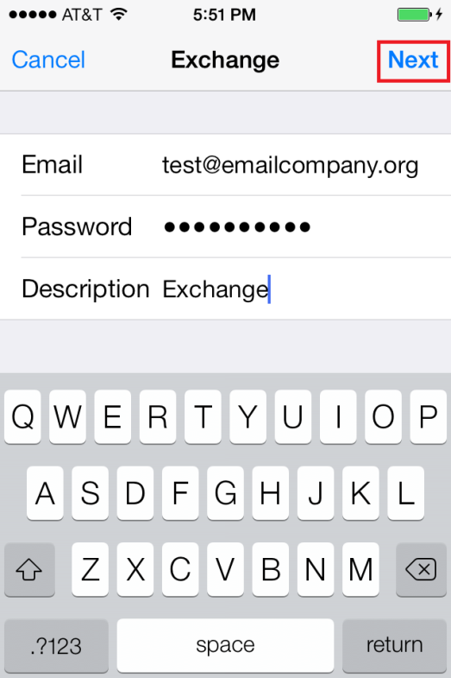

- Your iOS device will now try to locate your Exchange Server. If necessary, you will need to enter your front-end Exchange Server's complete address in the Server field.

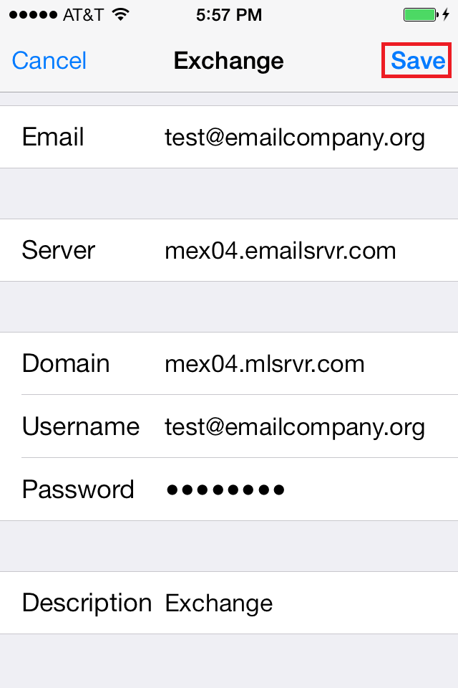
Email: Your Email Address
Server: owa.harborhcs.com
Domain: Harbor
Username: Your username (Without @harborhcs.com)
Password: Your password

- Choose which content you would like to synchronize: Mail, Contacts, and Calendars. Tap Save when finished.

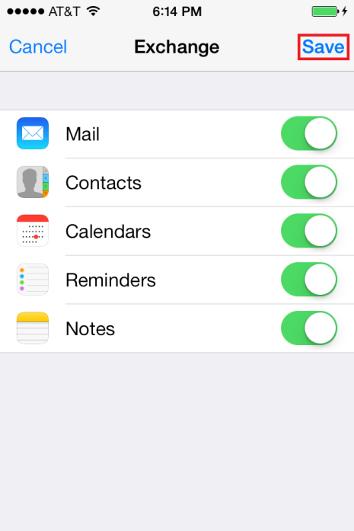
Note: To modify your exchange settings, Tap Settings > Mail, Contacts, Calendars, select your Exchange account, and tap Account Info.

